<< EBIZ WEB BOOKING SPLIT >>

*.This web page is for spilt booking information

-.Main screen shoot
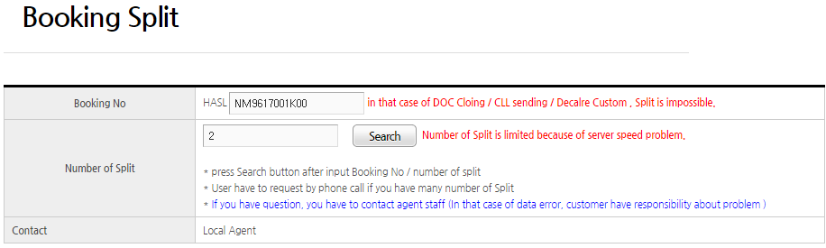
-.1) after input booking NO except “HASL” characters
-.2) input number of split booking NO that user want
-.3) press “Search” button
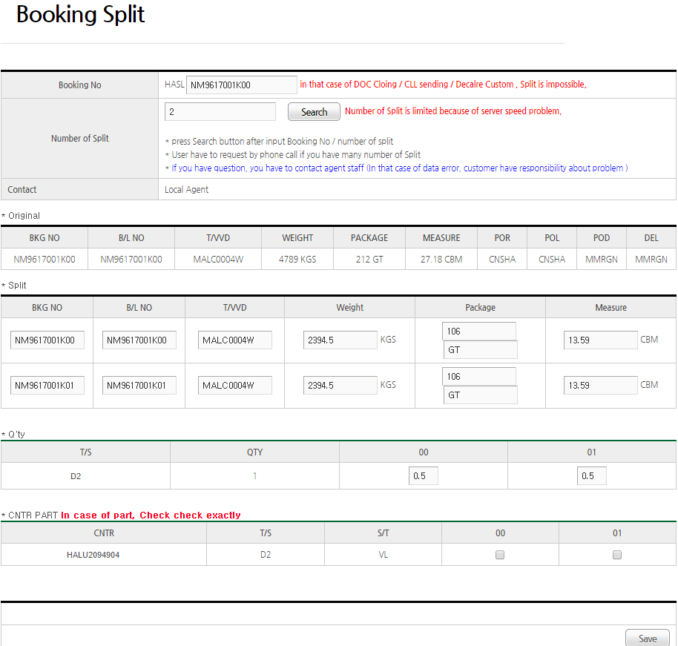
-.4) If user press “Search” button, original booking infomation will
be divided automatically
-.5) After input CNTR Qty(quantity) , weight /package/measure as user want,
Press “SAVE” button . and then original booking NO will be split

*.To use this webpage, user need to change internet explore option
in MenuBar -> Tools -> Compatibility View Settings
1) Add "heung-a.com" ( press "Add" button )
2)Check checkbox "Dispaly all websites in Compatibility view"
3)Press “Close” button

